# Kick Starter Campaign Performance from 2009-2017

By Jennifer Johansson

### Analysis

The most successful campaigns during this time period of 2009-2017 have to do with the fine arts. Kickstarter campaigns having to do with theater, music and film & video were the most successful.

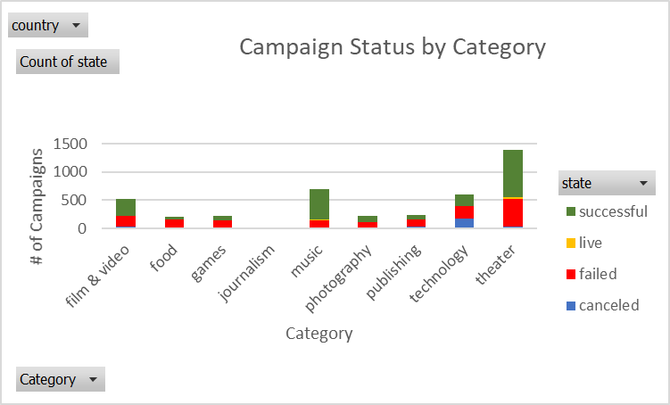

Within this theater category, the greatest volume of campaigns had to do with plays. Of all plays campaigns, 65% were successful.

Kickstarter campaigns gained popularity starting in 2013 and peaked in 2015. The dataset for 2017 is not complete.

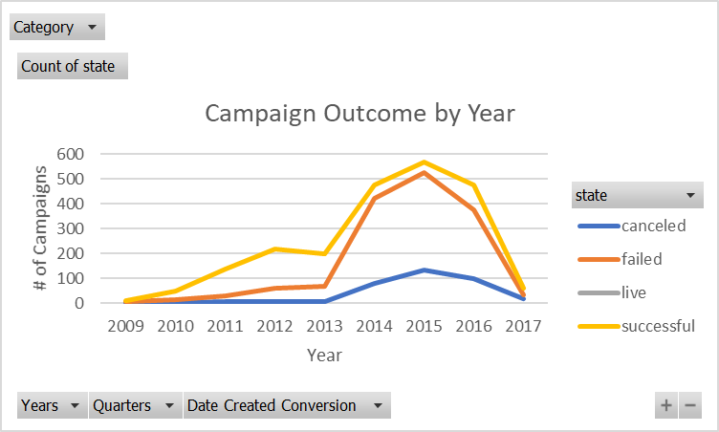

It’s interesting that campaigns launched in Q2 tend to be more successful than campaigns started in any other quarter.

## Limitations of the Dataset

It would be really interesting to have more demographic data around these campaigns, so that we could analyze if there was a region (ie within the US) or demographic that had more success than others. We can see that Canada, the US and Great Britain were the largest users of the Kickstarter program, but this could be based on many factors which cannot be deduced from the dataset (ie country population, propensity for charitable giving, politics, etc).

For the countries where only a few campaigns were launched, decisions should be limited for those countries because the sample size is too small.

## Additional Tables/Graphs

In order to perform the analysis above, I created several supplemental tables/charts:

1. Status and total count by country



1. Campaign Outcome by Year (shared above)
2. Campaign status by sub-category (shared above)

We could look at the dataset in more detail to discover:

1. Does the length of the campaign influence the outcome?
2. Is there an optimal time to leave a campaign running?
3. Does the optimal time vary by category? Country?